**Using IDLE**

<https://www.youtube.com/watch?v=lBkcDFRA958>

**To associate Python files with IDLE on Windows 8:**

1. Go to a folder that contains a Python file.
2. Right-click on any Python file.
3. Select **Properties**.
4. Next to the section that says “Opens with”, click the **Change** button.
5. You may need to select More Options.
6. Click on Look for another app on this PC.
7. Navigate to where you installed Python. For me, that’s the Python34 folder on the C drive.
8. Open Lib
9. Open idlelib
10. Select the idle.bat file.
11. Click **Open**.
12. Click **OK** to close out of **Properties**.
13. Now you can open .py files in IDLE simply by double-clicking on them.

**Follow these instructions to write and run a simple Python program using the IDLE editor:**

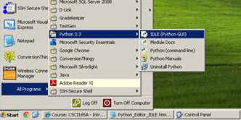

1. Start IDLE (see screen above). You will then see a window entitled "Python Shell" ...

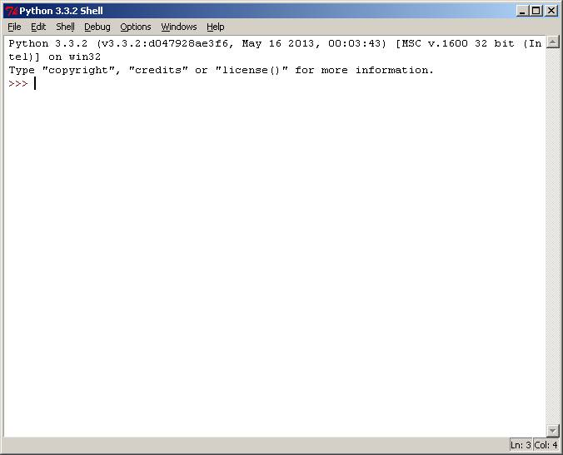

2. From the Python Shell window, select **New Window** from the **File** menu.

3. You will see a window entitled "Untitled"

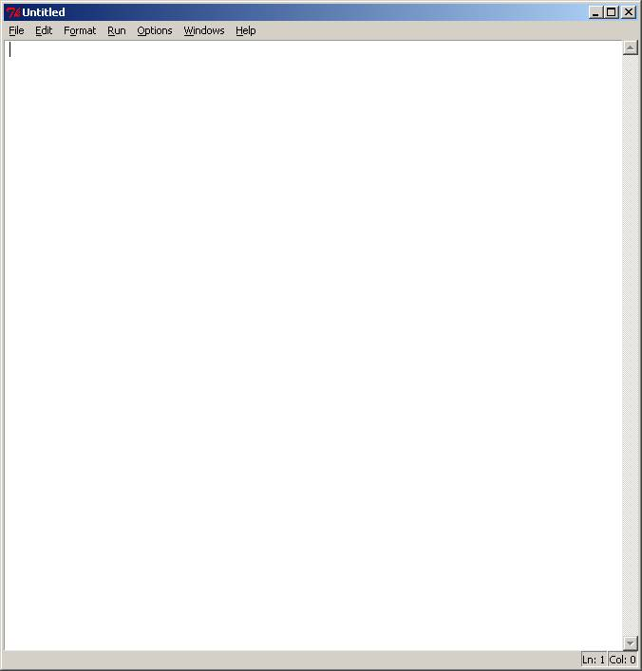

4. From the **File** menu, select **Save As**,

and select a folder to save your Python program file.

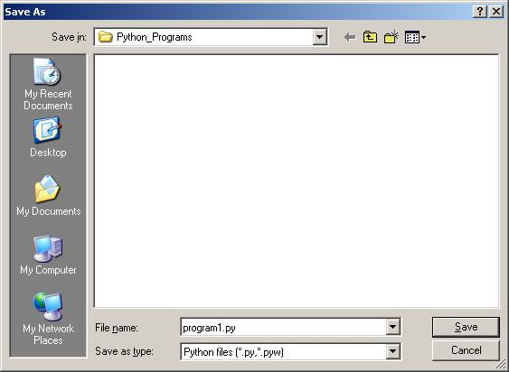

5. Select a folder to save your file in.

6. In the **File name:** text box, type: program1.py

7. Then click on the **Save** button.

You will then see a blank editor window ready

for you to type in your Python program.

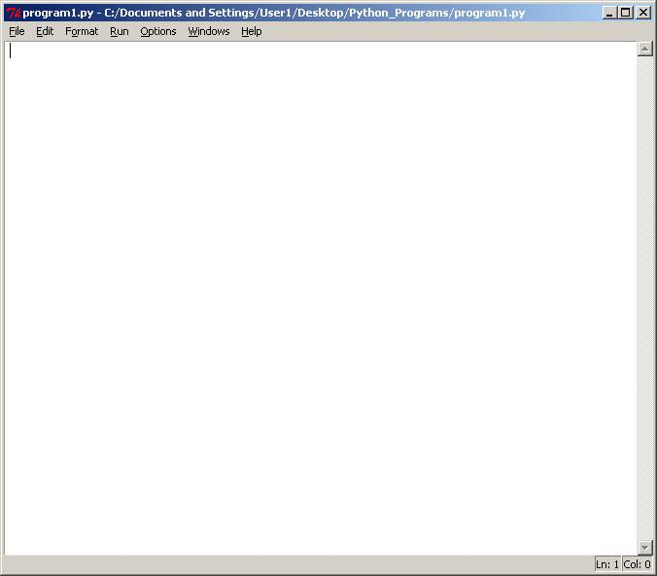

8. The following program statement will run under Python 2.x or Python 3.0

Type in the following text into this window

(make sure the word print is all in lower case):

print ("Hello World")

If you're running Python 2.x, the text will automatically change color to look like this:

print("Hello World")

**Note: we are using Python 3.x in this class**

If you're running Python 3.0.x, the text will automatically change color to look like this:

print("Hello World")

9. To run this program, select **Run Module** from the **Run** menu.

You should see a reminder to save the Source (your program).

Click on OK to save.

Then you will see your program running in a Python Shell window.

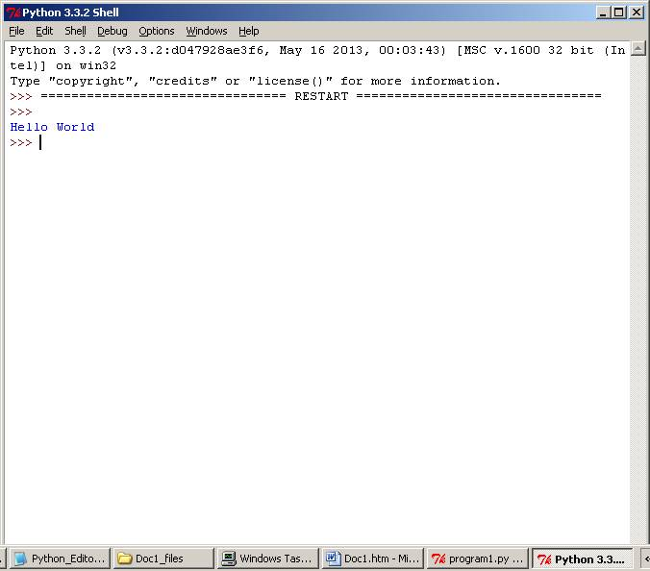

10. Close all Python windows to quit Python.

***IMPORTANT:***

**To open your Python file again,**

**locate the file in the folder,**

**click once on the file name it to highlight it,**

**then right-click on the mouse to see the options shown in**

**the screen below, and select *Edit with IDLE***

**to open the editor window.**

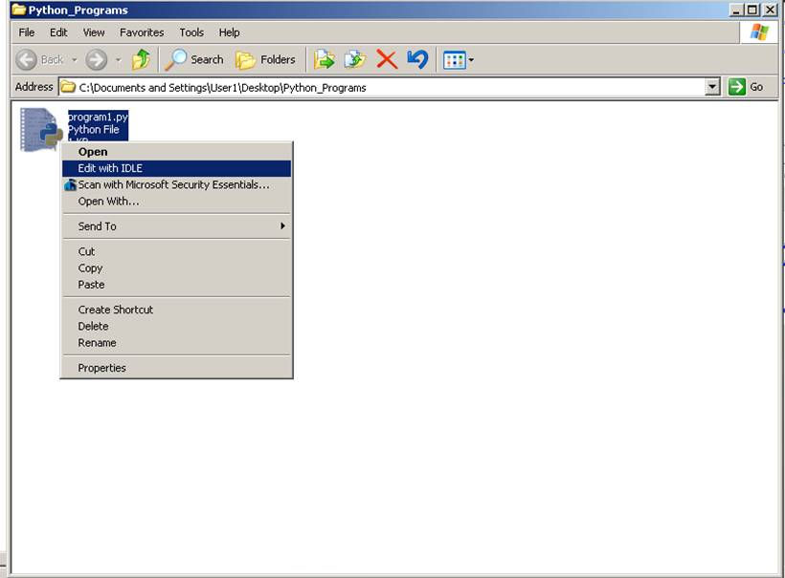

A Sample program:

* 1. **Creating and Executing a Python Program**

Playing around with Python commands in the shell window is nice, but our goal is to write complete Python programs. To do that, we need to start IDLE's editor. Here's how: From the Python Shell window, click on the File option on the menu bar, and select "New Window".

You will see a (surprise!) new window, one without a title. This is an editing window. Into it we can type sequences of Python commands to form programs. Unlike the shell window, we won't see the effect of the commands as we type them; we'll have to execute them as a group after we enter them to see what they do.

Into the new window, enter the following sequence of Python statements, just as you see them. Remember to press ENTER at the end of each line:

name = input("Please enter your name: ")

print("Hello, " + name + "!")

print("Your name has " + len(name) + " characters.")

Double-check that you typed the three lines exactly as you see them. Why is this a big deal? Because there is one intentional error in this program, and we're about to see how Python tells us about it. If you mistyped something, you may have created a second error, and if so the rest of this example won't go as we've planned.

Before IDLE will let Python execute this program, it will insist that we save the program as a file. This is a good idea; by saving it, we won't have to type it in again. Let's let IDLE nag us. In the menu bar, choose "Run", and from the drop-down menu choose "Run Module." Immediately, IDLE will pop up a little window that says, "Source Must Be Saved. OK to Save?" Click OK, and IDLE will show you a Save As window. Give it the name name.py and click "Save". Immediately, Python will start running your program; you'll have to look at the Python Shell window to interact with it.

In the shell window, you should see the "Please enter your name:" message. Go ahead and type in your name, followed by the ENTER key. The program will greet you, but then will encounter a problem. Here's what you should see in the Python Shell window (if your name is Rumpelstiltskin!):

Please enter your name: Rumpelstiltskin

Hello, Rumpelstiltskin!

Traceback (most recent call last):

File "name.py", line 3, in

print("Your name has " + len(name) + " characters.")

TypeError: Can't convert 'int' object to str implicitly

>>>

When you see a "Traceback" message block in red, you know that there's a problem with your program. In this case, as we mentioned above, we inserted an error intentionally. The problem is that we are trying to create a message by concatenating (gluing together, if you will) three pieces of information. That's allowed, but only if the pieces are all collections of characters. Here, len(name)produces a number, not a collection of characters, and so Python is not able to concatenate it with the surrounding characters.

To fix this error, go back to the program window (which is now named "name.py") and change len(name) to str(len(name)) without changing anything else. Choose "Run" and "Run Module" again, and Python will ask that you approve the saving of the source. Click "OK", and enter your name in the shell window again. If you entered the program accurately and made the change correctly, here's the result of the program's execution:

Please enter your name: Rumpelstiltskin

Hello, Rumpelstiltskin!

Your name has 15 characters.

>>>

One last thing: Go back to the "name.py" window and run the program one more time. Did you notice that IDLE didn't ask for the program to be saved? That's because you didn't change it since the last execution.

You now know enough to enter, save, and run Python programs using IDLE!

1. **Exiting IDLE**

When you're done, to leave IDLE all you have to do is close the windows. Because IDLE is so insistent that you save your program before each execution, it's hard to lose your changes when you leave IDLE. But, if you want to be really safe, you can save your program manually before closing the editing window. Choose "File" on the menu bar, and "Save" from the drop-down menu.